UNITED STATES

SECURITIES AND EXCHANGE COMMISSION
Washington, D.C. 20549

FORM 8-K

CURRENT REPORT

PURSUANT TO SECTION 13 OR 15(d) OF

THE SECURITIES EXCHANGE ACT OF 1934

Date of Earliest Event Reported: March 16, 2020

PENN NATIONAL GAMING, INC.

(Exact name of registrant as specified in its charter)

Pennsylvania | 0-24206 | 23-2234473
(State or Other Jurisdiction | (Commission | (IRS Employer
of Incorporation) | File Number) | Identification No.)

825 Berkshire Blvd., Suite 200

Wyomissing, PA 19610

(Address of principal executive offices including Zip Code)

610-373-2400

Registrant's telephone number, including area code

Check the appropriate box below if the Form 8-K filing is intended to simultaneously satisfy the filing obligation of the registrant under any of the following provisions:

- Written communications pursuant to Rule 425 under the Securities Act (17 CFR 230.425)

- Soliciting material pursuant to Rule 14a-12 under the Exchange Act (17 CFR 240.14a-12)

- Pre-commencement communications pursuant to Rule 14d-2(b) under the Exchange Act (17 CFR 240.14d-2(b))

- Pre-commencement communications pursuant to Rule 13e-4(c) under the Exchange Act (17 CFR 240.13e-4(c))

Indicate by check mark whether the registrant is an emerging growth company as defined in Rule 405 of the Securities Act of 1933 (§230.405 of this chapter) or Rule 12b-2 of the Securities Exchange Act of 1934 (§240.12b-2 of this chapter).

Emerging growth company ☐

If an emerging growth company, indicate by check mark if the registrant has elected not to use the extended transition period for complying with any new or revised financial accounting standards provided pursuant to Section 13(a) of the Exchange Act. ☐

Securities registered pursuant Section 12(b) of the Act:
 |  | Trading |  | Name of each exchange
Title of each class |  | symbol |  | on which registered
Common Stock, $0.01 par value per share |  | PENN |  | The Nasdaq Stock Market LLC

Item 8.01. Other Events.

In connection with Penn National Gaming, Inc.’s (“Penn National” or the “Company”) response to COVID-19, and subsequent to the Company’s Current Report on Form 8-K filed on March 16, 2020, Penn National issued the additional press releases attached hereto as Exhibits 99.1 – 99.11 of this Current Report on Form 8-K, which are incorporated herein by reference.

Item 9.01. Financial Statements and Exhibits.

(d) Exhibits.
Exhibit No. |  |  |  | Description of Exhibit
99.1 |  |  |  | Press Release dated March 16, 2020 of Penn National Gaming, Inc.
99.2 |  |  |  | Press Release dated March 16, 2020 of Penn National Gaming, Inc.
99.3 |  |  |  | Press Release dated March 16, 2020 of Penn National Gaming, Inc.
99.4 |  |  |  | Press Release dated March 16, 2020 of Penn National Gaming, Inc.
99.5 |  |  |  | Press Release dated March 17, 2020 of Penn National Gaming, Inc.
99.6 |  |  |  | Press Release dated March 17, 2020 of Penn National Gaming, Inc.
99.7 |  |  |  | Press Release dated March 17, 2020 of Penn National Gaming, Inc.
99.8 |  |  |  | Press Release dated March 17, 2020 of Penn National Gaming, Inc.
99.9 |  |  |  | Press Release dated March 17, 2020 of Penn National Gaming, Inc.
99.10 |  |  |  | Press Release dated March 18, 2020 of Penn National Gaming, Inc.
99.11 |  |  |  | Press Release dated March 18, 2020 of Penn National Gaming, Inc.

- Cover Page Interactive Data File (embedded within the Inline XBRL document).

SIGNATURES

Pursuant to the requirements of the Securities Exchange Act of 1934, the registrant has duly caused this report to be signed on its behalf by the undersigned hereunto duly authorized.

Dated: March 20, 2020

PENN NATIONAL GAMING, INC.

By: /s/ Carl Sottosanti

Carl Sottosanti
Executive Vice President, General Counsel and Secretary

-2-

Exhibit 99.1
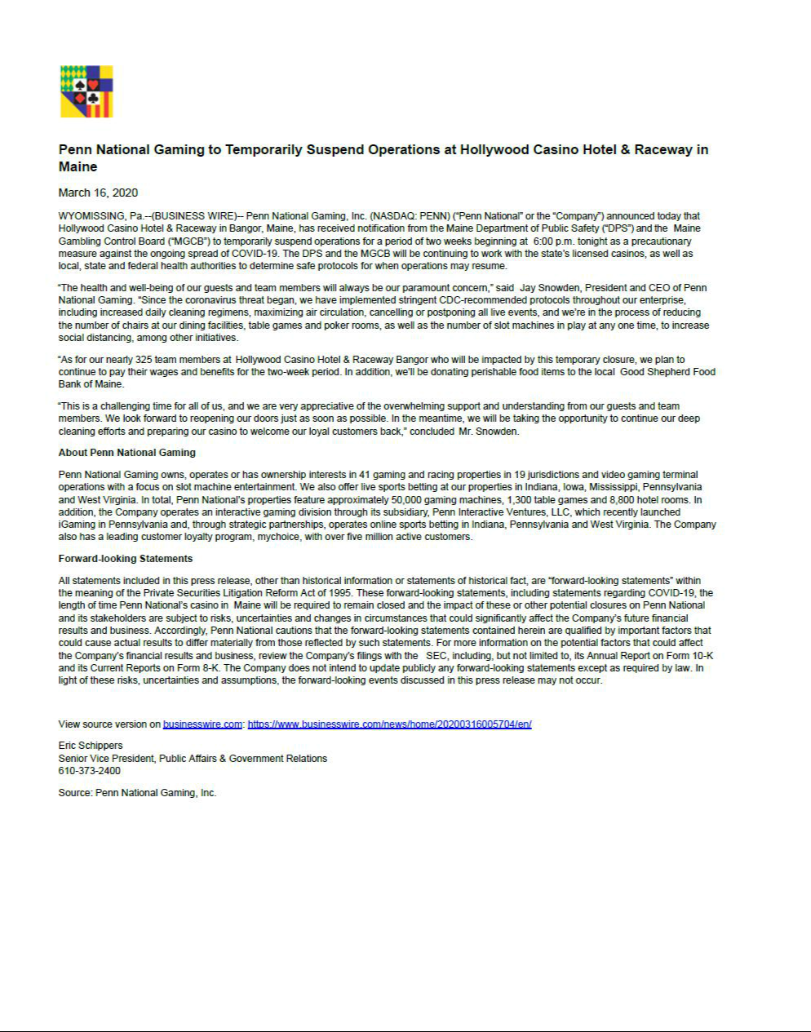

Exhibit 99.2
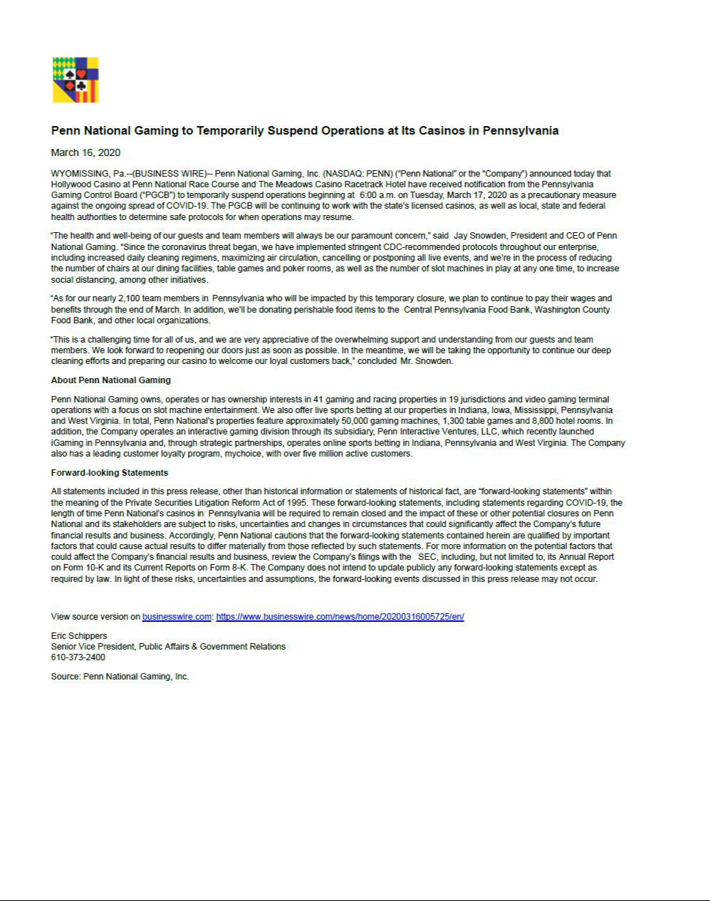

Exhibit 99.3
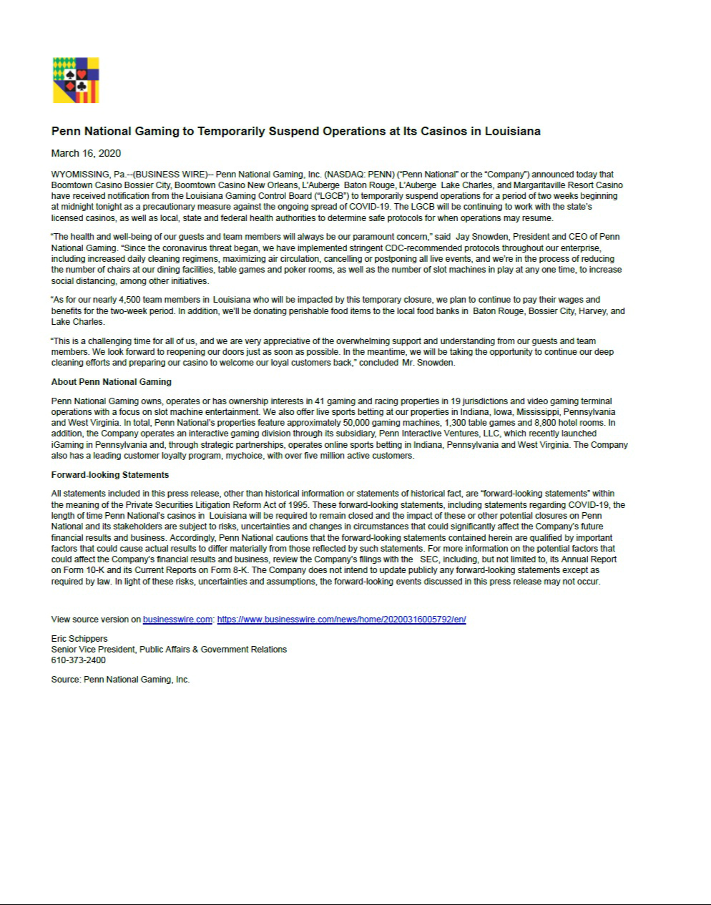

Exhibit 99.4
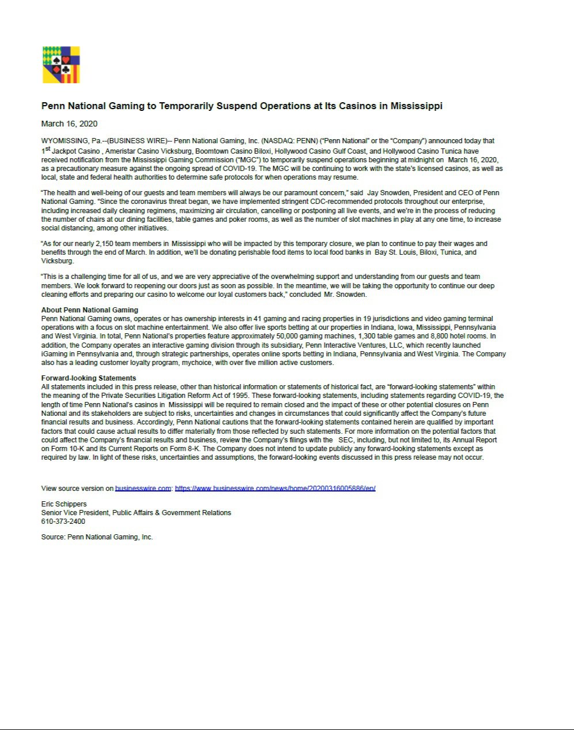

Exhibit 99.5
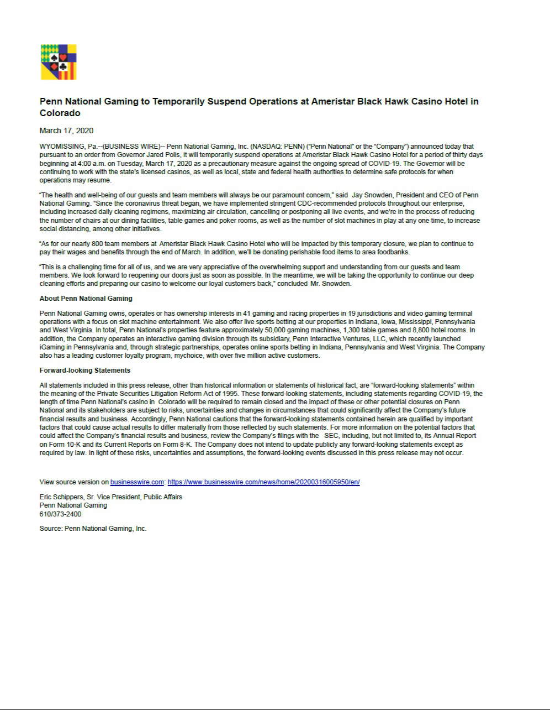

Exhibit 99.6
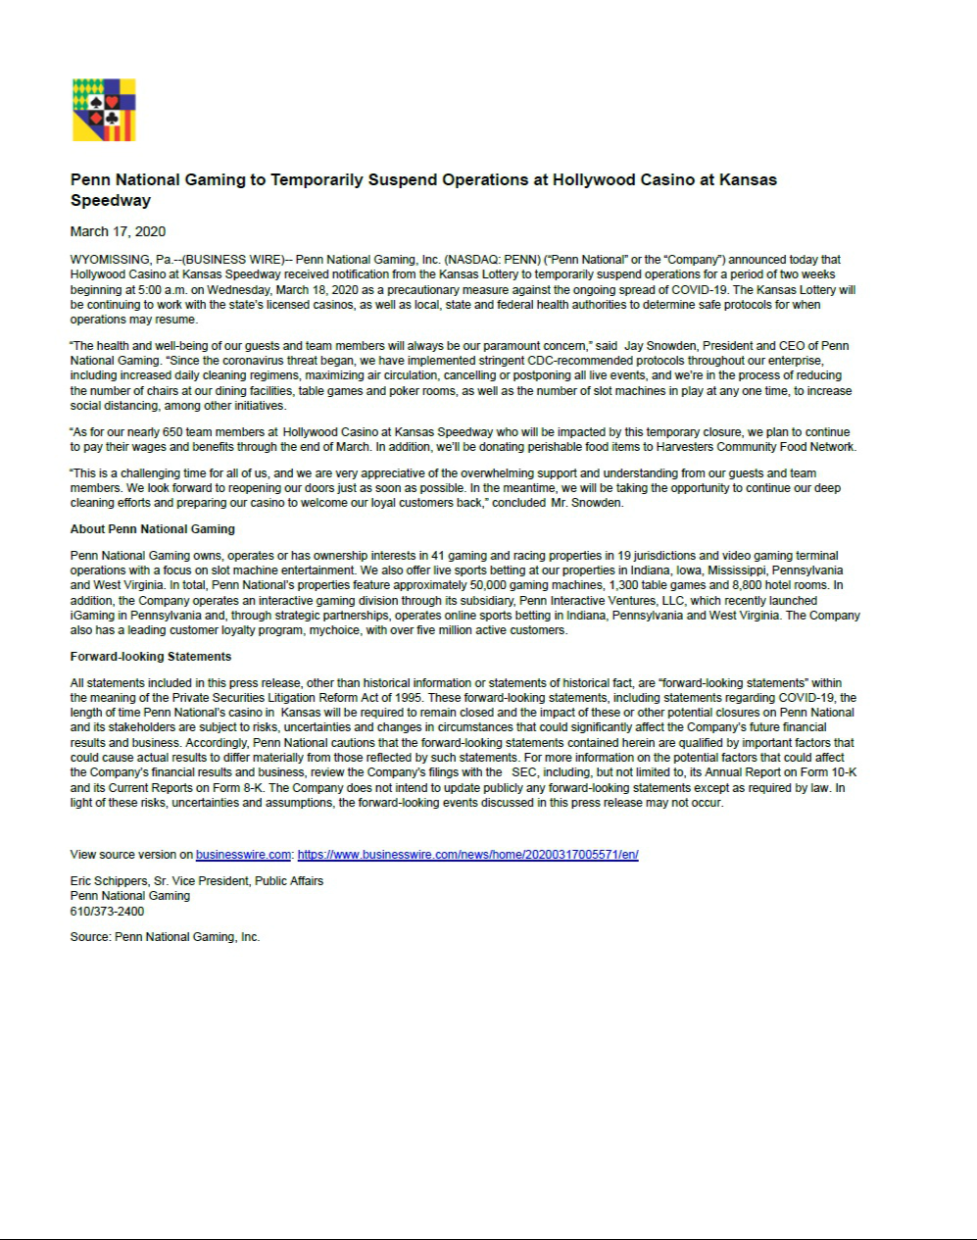

Exhibit 99.7
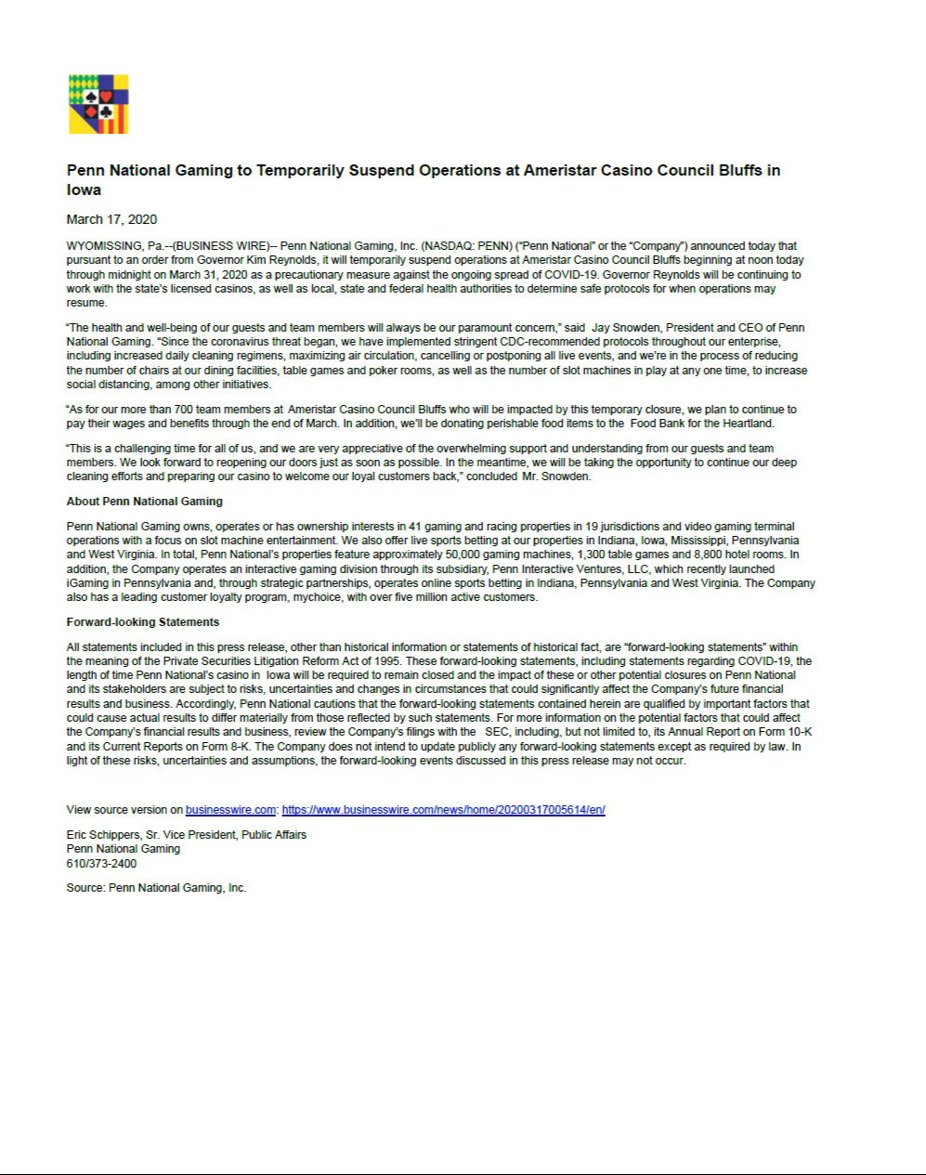

Exhibit 99.8
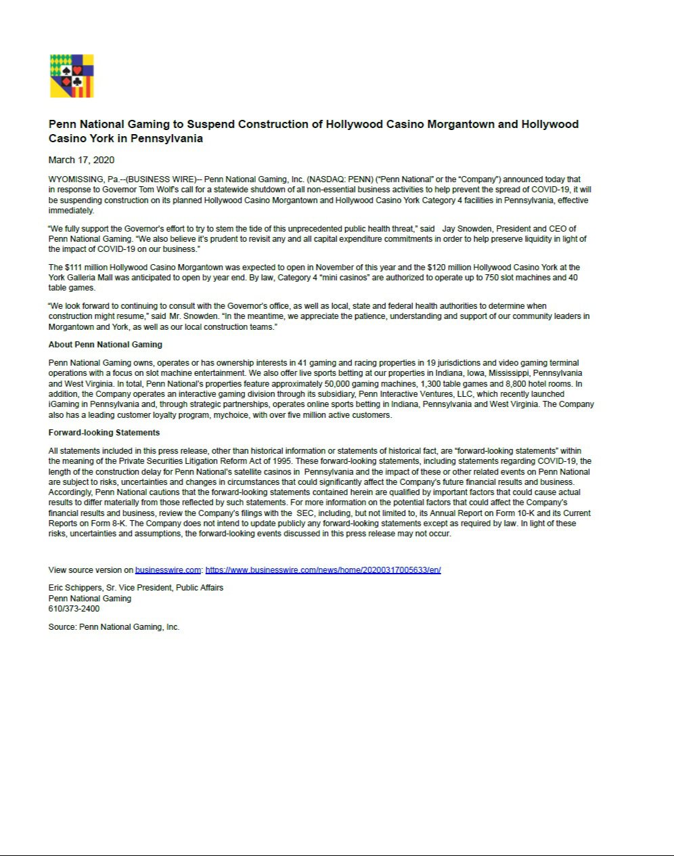

Exhibit 99.9
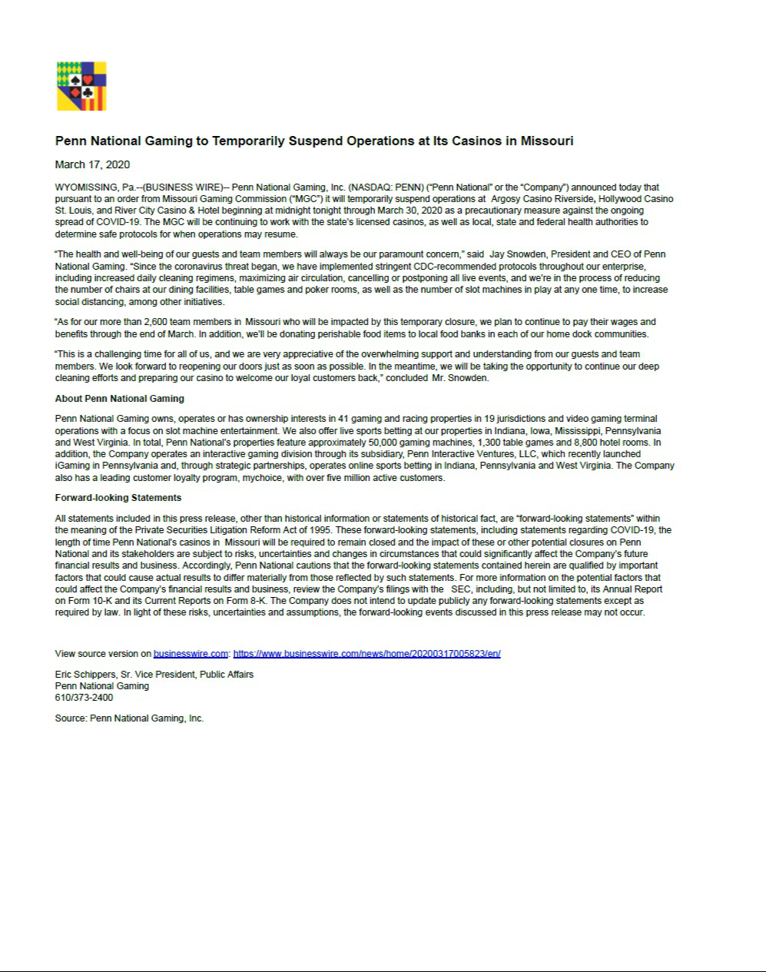

Exhibit 99.10
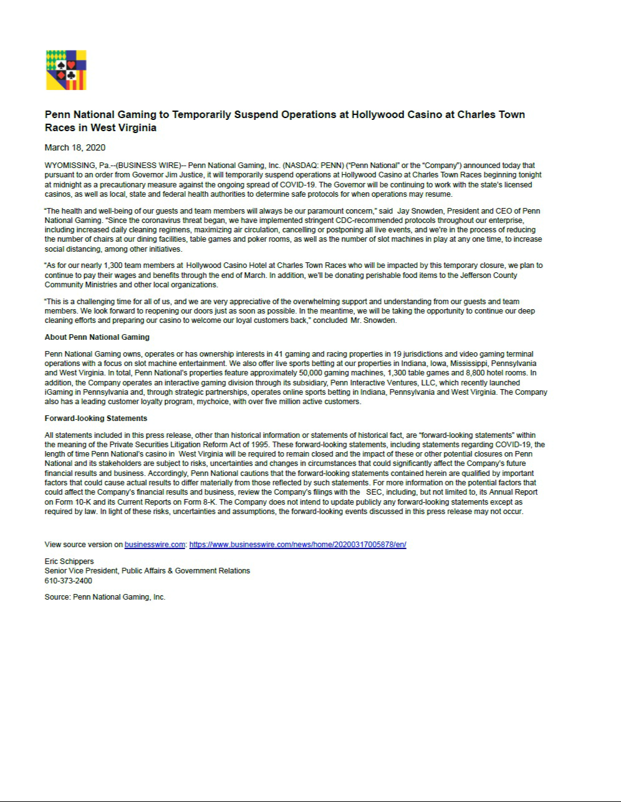

Exhibit 99.11


